Green infrastructure offsets increased land requirements under new Florida stormwater permitting criteria while enhancing nutrient load reduction
Higinio L Hernandez^{1*}
¹Graduate Student in the Master of Science in Engineering, Civil Engineering U.A. Whitaker College of Engineering, Florida Gulf Coast University, Fort Myers, Florida
*Corresponding author hlhernandezarenc5660@eagle.fgcu.edu

Abstract

Recent hurricanes have significantly impacted the Town of Fort Myers Beach, exposing limitations in existing stormwater management systems and increasing concerns related to flooding and water quality degradation. Concurrently, the Estero Bay watershed has experienced elevated nitrogen and phosphorus concentrations, contributing to ecological stress. Updated Florida regulations now require enhanced nutrient reduction and improved system performance. This study evaluates the effectiveness of a conventional stormwater management system under updated regulatory criteria and investigates whether the integration of green infrastructure can improve system performance using a 14.61-acre redevelopment site as a case study. A quantitative modeling approach using ICPR4 and BMP Trains was applied to evaluate system performance under two scenarios: conventional and green infrastructure. Hydrologic and hydraulic performance were assessed using ICPR4 modeling, while nutrient reduction was quantified using BMP Trains. Results indicate that the conventional system alone does not achieve the required nutrient reduction targets. In contrast, the integrated system incorporating green infrastructure achieves approximately 97% total nitrogen (TN) removal and 99% total phosphorus (TP) removal, exceeding the required 95% criteria. These findings demonstrate that green infrastructure is a critical component for achieving regulatory compliance in impaired coastal watersheds, as it reduces runoff at the source, enhances treatment efficiency, and offsets increased pollutant loading associated with development. Overall, this study provides evidence that hybrid stormwater systems offer a more effective and scalable approach for meeting current environmental permitting requirements while supporting sustainable coastal development.

1.0 Introduction
The project site is located in Fort Myers Beach, Lee County, on the north side of Estero right-of-way at the intersection of Estero Boulevard and Mound Road. Coastal regions such as Fort Myers Beach are increasingly vulnerable to intense rainfall events, sea level rise, flooding, and declining water quality. As an island, the site reflects this exposure, having been severely impacted by multiple hurricanes over the past decade. Recent regulatory updates, including SB 712 (Clean Waterways Act, 2020) and subsequent rulemaking, have established new stormwater treatment criteria implemented on December 28, 2025. These regulations strengthen water quality treatment requirements and raise performance standards. As a result, existing stormwater systems designed under previous criteria may no longer provide adequate flood protection or nutrient removal performance. Evaluating and redesigning the site’s stormwater management system under these updated criteria is essential to improve flood resilience, enhance water quality, and ensure compliance with district evaluation standards. This project proposes the assessment and redesign of the stormwater system for the site using hydrologic and hydraulic modeling, nutrient load analysis, and green infrastructure evaluation. The purpose of this study is to evaluate whether the existing and proposed stormwater management system (SWMS) can meet updated regulatory requirements and to identify improvements through integrated design approaches.
The project area, encompassing 14.61 acres, will undergo substantial reconstruction, including demolition of damaged buildings and parking areas, and construction of a new church building and associated infrastructure. The proposed SWMS, covering approximately 13.05 acres, will include a new church, parking, dry retention areas, and lakes designed to optimize stormwater conveyance, water quality, and flood protection. The existing SWMS was previously modified under Permit No. 36-103211-P and was designed based on earlier regulatory criteria and site conditions. Historically, stormwater flowed toward on-site detention areas before being conveyed to the existing lakes via conveyance swales. The existing system discharges off-site into the North Lake, which is tidally influenced and ultimately drains into Estero Bay. For this study, the proposed SWMS configuration, including dry retention areas and wet detention features, will be evaluated through modeling to determine its performance under updated Sout Florida Water Management District (SFWMD) criteria. The analysis focuses on flood control, nutrient reduction, and system compliance, with particular attention to the effectiveness of integrating green infrastructure into the design.

1,1 Literature Review and Research Gaps
Urban stormwater management has evolved significantly over the past decades; however, major challenges remain, particularly in coastal and redevelopment contexts. Traditional stormwater systems, commonly referred to as gray infrastructure, including pipes, ditches, dry and wet detention ponds, and infiltration basins, have historically been designed to rapidly convey runoff away from developed areas (Harper and Baker, 2007). While effective for flood control, these systems often exhibit variable pollutant removal efficiency and are not consistently capable of meeting current nutrient reduction requirements under updated Florida regulations (Rentachintala et al., 2022). Harper and Baker (2007) reported that total phosphorus (TP) removal ranges from approximately 61% to 95%, while nitrogen removal can reach up to 90% under optimal conditions; however, these results depend strongly on system design and were developed under earlier regulatory criteria, limiting their applicability to current SFWMD standards. To address these limitations, hydrologic and hydraulic modeling tools have become essential for evaluating stormwater system performance under Florida-specific conditions. The Interconnected Channel and Pond Routing (ICPR4) model is widely used to simulate stormwater conveyance, storage, and discharge in low-gradient coastal environments where groundwater interaction and tidal influence are significant. Joyce et al. (2017) developed a multi-scale modeling framework for coastal stormwater systems, demonstrating that system performance is influenced by rainfall variability, groundwater conditions, and sea level rise. However, their analysis primarily focuses on hydraulic response and flood resilience, with limited integration of water quality processes. Similarly, Schroeder et al. (2022) showed that ICPR4-based modeling improves representation of system behavior and supports regulatory compliance, particularly when combined with spatial analysis tools. In parallel, stormwater treatment performance in Florida is commonly evaluated using Best Management Practices (BMPs) and planning-level tools such as BMP Trains, which estimate nutrient load reductions based on land use, runoff characteristics, and treatment system configuration. Wanielista et al. (2013) demonstrated that BMP systems reduce pollutant loads through filtration, adsorption, and biological processes, and that stormwater harvesting reduces nutrient discharge by decreasing runoff volume. These findings emphasize that treatment performance is strongly dependent on system configuration and hydraulic conditions. However, most BMP-based studies evaluate individual treatment components rather than overall system performance at the site scale, which is required for regulatory compliance. More recently, the transition from gray to green infrastructure has gained attention as a strategy to improve stormwater system performance. Tsegaye et al. (2019) introduced the Gray-to-Green approach, which integrates green infrastructure practices within urban systems to manage stormwater at or near its source, providing benefits such as runoff reduction, increased infiltration, and improved water quality. Similarly, Rentachintala et al. (2022) emphasized the importance of integrating sustainable stormwater practices with modeling approaches to address evolving environmental challenges. However, these studies are generally broad in scope and do not provide detailed, site-specific evaluations of green infrastructure performance under updated Florida permitting criteria. Regulatory frameworks also play a critical role in stormwater system design. Florida Statutes Section 373.4131 establishes statewide environmental resource permitting requirements, including post-development nutrient reduction targets and criteria for impaired waters (Florida Senate, 2025). Under these regulations, stormwater systems must demonstrate both hydraulic performance and nutrient reduction through modeling and quantitative analysis. Consequently, this shift toward stricter performance standards increases the need for integrated approaches that combine hydrologic, hydraulic, and water quality evaluation within a unified framework (Rentachintala et al., 2022). Although previous studies provide valuable insights into stormwater system performance, several limitations remain that justify further investigation. Existing research demonstrates the effectiveness of hydrologic and hydraulic modeling tools, but there is limited integration of water quality analysis within these frameworks for coastal stormwater systems subject to tidal influence and climate variability (Joyce et al., 2017; Schroeder et al., 2022). In addition, while BMP studies show effective nutrient removal at the component level, there is a lack of linkage between BMP-scale performance and site-scale regulatory compliance (Wanielista et al., 2013). Furthermore, research on real-time monitoring and stormwater reuse systems highlights opportunities to improve system efficiency, but these approaches are not commonly integrated into predictive modeling frameworks used during system design (Wanielista, 2005). Finally, there is limited data evaluating stormwater system performance under updated Florida regulatory criteria for coastal redevelopment sites, particularly where increased impervious area and constrained site conditions influence both hydraulic response and nutrient loading (Tsegaye et al., 2019; Rentachintala et al., 2022).
This study addresses these gaps by evaluating the performance of a SWMS under updated Florida regulatory conditions using an integrated modeling framework. The research combines ICPR4 for hydrologic and hydraulic simulation with BMP Trains for nutrient load analysis to assess both water quantity and water quality performance. The central research question is: Can a conventional stormwater management system meet updated nutrient reduction requirements, and to what extent can green infrastructure improve total nitrogen (TN) and total phosphorus (TP) reduction?
The study proposes to:
(1) assess site hydrology, evaluate existing system conditions, and flooding impacts;
(2) model stormwater conveyance and water quality treatment using design storm events and ICPR4 and BMPs Train modeling;
(3) explore green infrastructure alternatives for improved nutrient reduction; and
(4) develop a compliant and sustainable stormwater management system for the subject area.
The outcomes will provide design recommendations for the project site and serve as a replicable framework for other coastal developments in South Florida. In addition, the study offers a structured and integrated approach for evaluating stormwater system performance under updated regulatory conditions, supporting improved engineering design and decision-making for similar coastal projects.

2.0 Methods
The methodology for this study applies a structured and reproducible framework to evaluate stormwater system performance under updated regulatory conditions. The approach is designed to guide the evaluation of both conventional and green infrastructure scenarios by linking data collection, model development, and performance assessment. First, a mixed data collection approach was implemented, incorporating Environmental Resource Permit (ERP) documentation, existing hydrologic models, and supplementary regional datasets. Key inputs, including grading plans, detention features, and control structures, were used to define model geometry and boundary conditions. Additionally, site-specific data such as survey/topographic information, USDA soil classifications, and FEMA Flood Insurance Rate Maps were integrated to ensure accurate representation of existing conditions. Supplementary datasets, including NOAA rainfall IDF curves and TR-55 parameters, were used to refine hydrologic inputs and maintain consistency with established modeling practices. Next, these inputs were used to develop the hydrologic and hydraulic models, allowing simulation of runoff generation, storage, and discharge under design storm conditions. Field verification was conducted to validate model assumptions and confirm hydraulic connectivity across the site, ensuring that flow paths and elevations reflect actual site conditions. Finally, the processed data were applied within ICPR4 and BMP Trains models to evaluate system performance, where ICPR4 was used to simulate hydraulic behavior and BMP Trains was used to quantify nutrient loading and removal. This step enables direct comparison of system performance across design scenarios, supporting assessment of regulatory compliance and identification of improvements provided by green infrastructure.

2.1 System Performance Evaluation criteria

2.1.1 Hydraulic Performance Criteria
To evaluate the proposed SWMS, regulatory and hydraulic performance criteria were established based on Lee County requirements, FEMA floodplain standards, and SFWMD Environmental Resource Permit design criteria. First, hydraulic performance is evaluated by simulating system response using ICPR4 under standard design storm events, including the 10-year 1-day, 25-year 3-day, and 100-year 3-day storms.

These events represent regulatory design conditions and are used to quantify peak stage, storage capacity, and allowable discharge within the basin. Next, model outputs are used to establish critical design elevations for site infrastructure, where the peak stage from the 10-year storm stage defines the minimum parking lot elevation, and the 25-year storm stage defines roadway and perimeter berm elevations. This step ensures that infrastructure elevations are directly linked to modeled system performance and comply with flood protection requirements. Then, building protection is evaluated by comparing modeled peak stages with FEMA flood elevations, where the governing elevation is defined as the higher of the FEMA Base Flood Elevation plus one foot or the 100-year 3-day peak stage, and finished floor elevations are set at FEMA Base Flood Elevation plus two feet of freeboard to ensure compliance with floodplain management standards. Finally, system performance is assessed in the context of watershed conditions, as the project site is located within HUC12-030902040107 and discharges to the Estero Bay Basin, where nitrogen is identified as an impaired parameter. This condition requires that the hydraulic evaluation be considered alongside water quality performance to ensure that the system meets both flood control and regulatory compliance objectives under impaired watershed conditions.

2.1.2 Nutrient Reduction Criteria
Following the hydraulic evaluation, nutrient reduction criteria were applied based on updated SFWMD requirements to assess water quality performance. First, regulatory thresholds are defined using Table 1, which establishes the required TN and total TP removal percentages used to evaluate system compliance. These thresholds depend on site location and are determined by comparing pre- and post-development pollutant loads. Next, the project site is classified within watershed boundary HUC12-030902040107, which discharges to the Estero Bay Basin where nitrogen is identified as an impaired parameter, requiring enhanced treatment performance. Because the site is within the same HUC-12 and upstream of impaired waters, the applicable criteria require a minimum nutrient reduction of 95 percent for both TN and TP. Then, this requirement is applied as the primary performance metric in the water quality analysis, where modeled post-development loads are evaluated against baseline (pre-development) conditions. This step ensures that the system not only achieves the required percentage reduction but also meets the regulatory condition of no net increase in pollutant loading. Finally, system performance is assessed by verifying that the proposed design achieves both the 95 percent reduction target and a net improvement for the impaired pollutant, ensuring compliance with SFWMD criteria and supporting protection of downstream water quality.
Table 1. Updated SFWMD Criteria for Evaluation.
Project Location | Nutrient Reduction Requirements | Additional Criteria
All Sites (Minimum) | - 80% reduction TP  - 55% reduction TN | Or post ≤ pre
Upstream of OFW | - 90% reduction in TP  - 80% reduction in TN | Or post ≤ pre
Upstream of Impaired Waters | - 80% reduction in TP  - 80% reduction in TN | And post ≤ pre plus net improvement for the pollutant of concern
Upstream Impaired + OFW | - 95% reduction in TP  - 95% reduction in TN | And post ≤ pre plus net improvement
Redevelopment | - 80% reduction in TP  - 45% reduction in TN | N/A
Redevelopment + OFW | - 90% reduction in TP  - 60% reduction in TN | N/A
Redevelopment + Impaired | - 80% reduction in TP  - 45% reduction in TN | And net improvement for the pollutant of concern

2.2 Hydrologic and Hydraulic Modeling- ICPR4

2.2.1 Basis of Design and Assumptions
Design assumptions were derived from the SFWMD Design Manual to ensure consistency with regulatory modeling standards. First, rainfall inputs are defined using the SFWMD 72-hour and FDOT 24-hour distributions to represent required design storm conditions, and all elevations are referenced to the North American Vertical Datum of 1988 (NAVD 88) to maintain consistency across hydraulic calculations. Next, hydrologic parameters are established using standard methods to simulate runoff generation and basin response, where the time of concentration is calculated as a function of contributing drainage area to represent runoff travel time, and runoff potential is estimated using the Soil Conservation Service (SCS) Curve Number method in accordance with SFWMD guidance. Soil conditions, including Canaveral fine sand and Matlacha gravelly fine sand, are incorporated to define infiltration capacity and storage characteristics, and curve numbers and available storage are assigned based on soil properties, groundwater conditions, and the proportion of directly connected impervious areas. Then, boundary conditions are defined to represent downstream hydraulic influences, where North Lake is used as the receiving water body and tailwater elevations are obtained from NOAA Fort Myers Station (ID: 8725520) to capture tidal effects. The control elevation of 1.60 ft NAVD is applied to represent the existing discharge structure and hydraulic connection to North Lake. Finally, storage representation is defined using stage-storage relationships to simulate how runoff is stored and released within the basin, where lakes and dry retention areas are modeled using vertical storage from the control elevation, and other land uses are represented using linear storage from ground elevation. Building footprints are excluded from storage calculations to prevent overestimation of available storage capacity. These assumptions collectively enable the ICPR4 model to simulate runoff routing, storage behavior, and hydraulic performance in a manner consistent with site conditions and regulatory evaluation criteria.
Figure 1 is used to relate these assumptions to basin conditions by illustrating pre- and post-development land use and impervious changes, which directly influence runoff generation and nutrient loading. Similarly, Table 2 defines the design storm inputs used in the model, ensuring that rainfall conditions applied in the analysis are consistent with NOAA Atlas 14 regulatory data.
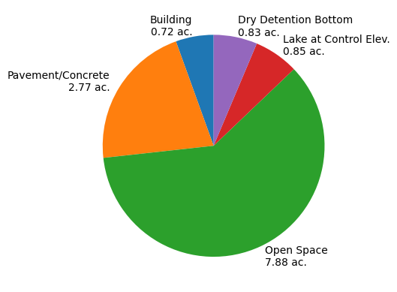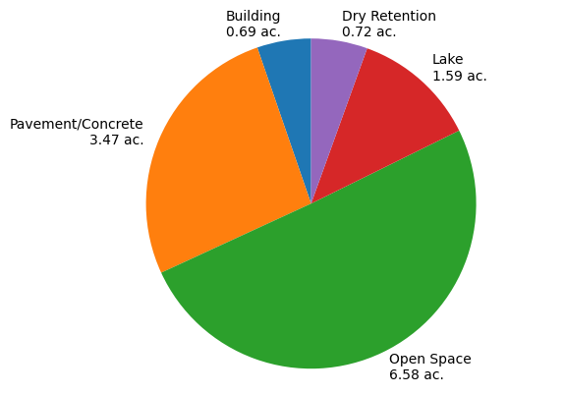
(a) | (b)
Figure 1. Basin Land Use areas . (a) Pre-development; (b) Post-development.
Table 2. Design Storms
Return Frequency | Rainfall Duration | Rainfall Intensity
10 Year | 1 Day (24 hrs) | 7.20 in.
25 Year | 3 Day (72 hrs) | 11.20 in.
100 Year | 3 Day (72 hrs) | 15.10 in.

2.2.2 Model setup
The hydrologic and hydraulic model for the site was developed using ICPR44, incorporating site-specific basin and infrastructure data to simulate system performance under design storm conditions. First, the system is represented as a single basin with an area of 13.05 acres to simplify the modeling framework while preserving hydraulic behavior, and runoff generation is simulated using the NRCS Unit Hydrograph method with a time of concentration of 17 minutes. Infiltration is represented by using the Curve Number method with a CN of 74.3, reflecting the 41% impervious area of the basin and ensuring consistency with site conditions. The initial stage of the basin is set at 1.60 ft to represent existing control elevations. Next, hydraulic routing is defined to simulate how water moves through the system, where stage-volume and time-stage relationships are applied to both the basin and outfall components. The outfall is initialized at 2.18 ft and controlled using a sharp-crested vertical weir, while hydraulic connectivity between the basin and outfall is represented through pipe and drop structures. The drop structure is modeled as a circular pipe with an invert elevation of 1.60 ft, Manning’s n of 0.013, and a length of 60 ft, and the downstream weir is defined with a discharge coefficient of 3.2 to regulate flow. Model parameters are configured to ensure stable and accurate simulation of flow routing and energy losses throughout the system. Then, simulation conditions are applied to evaluate system performance under regulatory storm events, where model runs include the design storms defined in Table 2. A SAOR time-marching scheme is used, with time steps selected based on storm duration and system response to maintain numerical stability and capture dynamic hydraulic behavior.
Finally, model outputs are analyzed to evaluate flow routing, peak stages, and discharge rates across all scenarios, ensuring consistency with regulatory criteria and supporting comparison of system performance under different design conditions. Figure 2 illustrates the modeled flow path from the basin through the control structure to the outfall, providing a visual representation of the hydraulic routing framework used in the analysis.

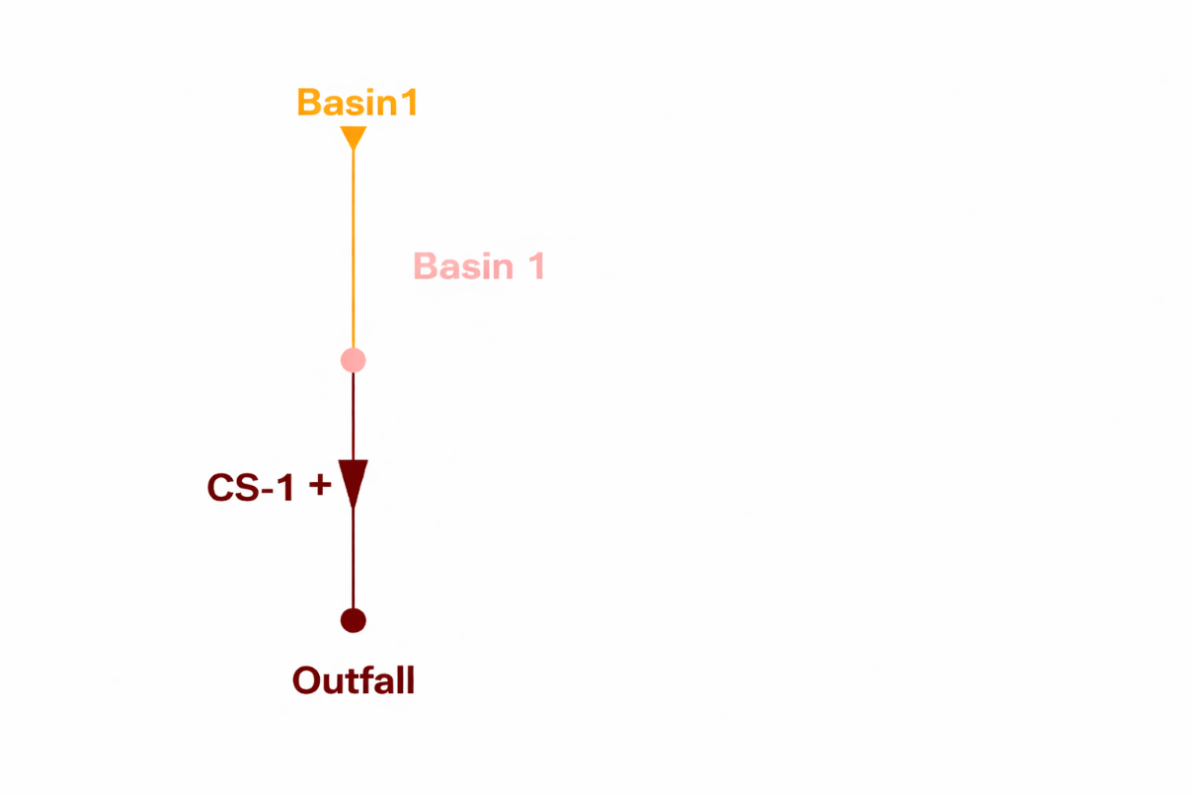
Figure 2. ICPR44. Node/Stage diagram.

2.3 Water Quality Modeling and Nutrient Load Analysis

2.3.1 Pre-Development Analysis
The project site consists of two primary soil types, Canaveral fine sand (HSG A) and Matlacha gravelly fine sand (HSG B), comprising 80.8% and 19.2% of the site, respectively. To begin, the pre-development condition is evaluated using BMP Trains to establish a baseline for comparison with post-development scenarios and regulatory targets, based on a total contributing drainage area of 13.05 acres within Florida Zone 4, with an average annual rainfall of 52 inches. The existing land use is characterized as low-intensity commercial across the basin. Hydrologic response is defined using a Curve Number (CN) of 56 for pervious areas and a directly connected impervious area (DCIA) of 33 percent, representing runoff generation under existing conditions. Event mean concentrations (EMCs) of 1.130 mg/L for TN and 0.188 mg/L for TP are applied to quantify pollutant loading, consistent with BMP Trains guidance for this land use category. Subsequently, these inputs are used to compute annual nutrient loads, resulting in 23.11 kg/year for TN and 3.84 kg/year for TP. This step establishes the reference condition against which post-development performance is evaluated, ensuring that changes in runoff and pollutant loading can be directly quantified and compared to SFWMD regulatory requirements.

2.3.2 Post-Development Analysis
The post-development condition maintains the same drainage area and land use classification; however, site modifications are incorporated to evaluate the impact of increased impervious coverage on system performance. Specifically, the directly connected impervious area (DCIA) increases from 33 percent to 40 percent, while the pervious Curve Number decreases slightly to 55, indicating higher runoff potential and reduced infiltration capacity. As a result, runoff generation is recalculated, yielding an annual runoff volume of 17.76 acre-feet per year. EMC values for TN and TP remain unchanged due to consistent land use classification; however, the increase in runoff volume leads to higher total nutrient loads, with TN increasing to 24.74 kg/year and TP to 4.12 kg/year. This represents increases of approximately 7.1 percent and 7.0 percent, respectively, compared to pre-development conditions. These results are then evaluated against regulatory criteria, demonstrating that additional treatment is required to achieve the 95% nutrient reduction target and prevent net increases in pollutant loading. Finally, system components such as the 1.59-acre wet pond are incorporated as treatment features rather than pollutant sources, contributing to nutrient removal within the overall system.

2.4 Stormwater Management System design and Evaluation Scenarios

The proposed SWMS is configured as a treatment train in which runoff is conveyed from dry retention to wet detention prior to discharge. Initially, runoff is directed to dry retention areas, where storage and infiltration reduce runoff volume and provide preliminary nutrient removal; subsequently, flow is routed to the wet pond, where additional storage, sedimentation, and biological uptake enhance treatment efficiency before discharge. This configuration represents the baseline (conventional) system used to evaluate compliance under updated criteria. To assess system performance, two scenarios are defined for comparative analysis, including (1) a conventional system consisting of dry retention followed by wet detention and (2) an enhanced system incorporating green infrastructure components such as green roofs and stormwater harvesting. These scenarios enable direct evaluation of treatment efficiency and regulatory compliance under consistent modeling conditions. The retention depth for dry retention areas is set at 1.20 feet to define available storage capacity. In addition, wet detention geometry is specified using key elevation parameters, including a control elevation of 1.60 ft NAVD, slope break at −5.40 ft NAVD, and bottom elevation at −10.40 ft NAVD. Only Lake 1 meets the SFWMD minimum area requirement and is included as a treatment component, while Lake 2 is excluded from performance evaluation. Figure 3 supports this analysis by illustrating storage–depth relationships, allowing verification of treatment capacity across the contributing drainage area.
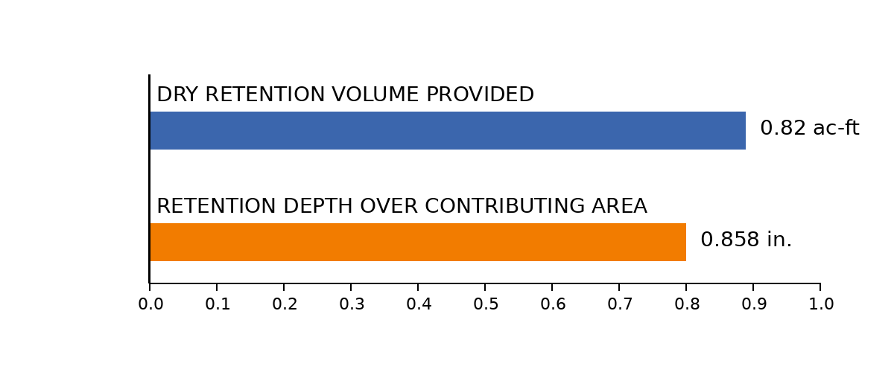
Figure 3. Dry Retention Storage Volume and Retention Depth over Contributing Area.

2.4.1 Convectional System Configuration
BMP Trains is applied as a planning-level model consistent with Florida permitting practice to evaluate baseline system performance. To begin, the model is configured using a standardized workflow to ensure reproducibility, including General Site Information (Florida Zone 4, 52 inches rainfall), Watershed Characteristics (drainage area, curve number, directly connected impervious area, and EMC values), Treatment Options (selection and parameterization of BMPs), and Catchment Configuration (definition of flow routing). These inputs are used to compute runoff volumes and nutrient loads, forming the basis for comparison across design scenarios. Subsequently, the baseline treatment train is defined, where runoff is routed from the contributing drainage area through dry retention and then wet detention prior to discharge. This configuration establishes the conventional system used to evaluate compliance with regulatory requirements. In addition, routing between BMP components is explicitly defined to simulate flow paths, as treatment efficiency is dependent on BMP sequencing and hydraulic connectivity. Finally, model outputs are analyzed using the Summary Treatment Report, where annual runoff, nutrient loads, percent removal, and compliance metrics are evaluated against the 95% reduction target and no-net-increase requirement. Figure 4 supports this configuration by illustrating the BMP sequencing and routing structure used to evaluate system performance.
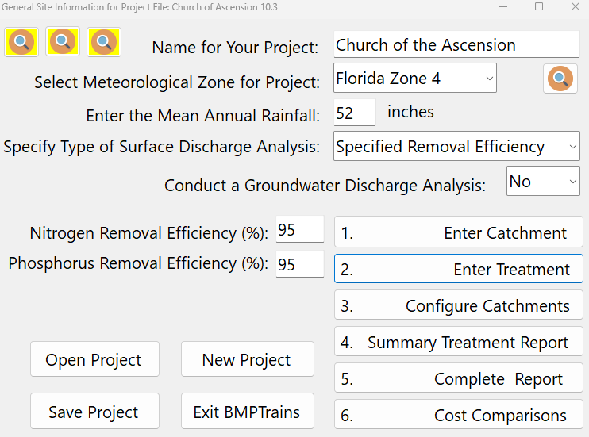 | 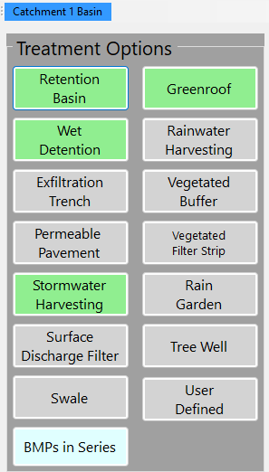
(a) | (b)
Figure 4. BMPs Train Model Analysis. (a) Case Study model setup; (b) Treatment Options.

2.4.2 Green infrastructure design alternatives
To address performance limitations identified in the conventional system, green infrastructure alternatives are incorporated to enhance treatment efficiency and regulatory compliance. Initially, an enhanced scenario is developed by integrating green roof and stormwater harvesting systems with the baseline treatment train, maintaining consistent modeling assumptions to allow direct comparison. The green roof is defined with an area of 21,069 ft² and a storage depth of 1 inch, and is parameterized using local rainfall data from the Fort Myers station to simulate runoff reduction through interception and evapotranspiration. Additionally, stormwater harvesting is incorporated to capture and reuse runoff, serving an irrigation area of 6.58 acres with a total storage volume of 1.24 acre-feet and a harvest rate of 0.2 inches per week. Together, these components are applied to reduce inflow to downstream BMPs, increase effective residence time, and enhance nutrient removal efficiency. Finally, the enhanced system is evaluated against the 95% TN and TP reduction requirement, allowing quantification of performance improvements relative to the conventional system and verification of compliance under updated SFWMD criteria.

Results

3.1 System performance under new criteria

3.1.1 Hydraulic Performance Results
ICPR4 4 modeling was performed for the 10-year 1-day, 25-year 3-day, and 100-year 3-day design storms to determine peak water surface elevations and discharge from the proposed 13.05-acre development. First, results indicate that all simulated peak stages remain below critical design elevations, including berms, roadway crowns, parking areas, and finished floor elevations, confirming adequate flood protection under all regulatory storm events. The initial control elevation was set at 1.60 ft to maintain positive conveyance. These results demonstrate compliance with SFWMD and Lee County hydraulic performance criteria. Building floor elevations are set at FEMA elevation plus 2 feet, with FEMA flood elevation governing the final design to ensure conservative flood protection. Next, discharge analysis confirms that post-development flow remains within allowable limits, with a maximum discharge of 15.35 cfs compared to the allowable 23.00 cfs for the basin. This indicates that the system effectively controls peak discharge and prevents downstream impacts. Table 3 summarizes the minimum allowable and recommended elevations for the site. Moreover, figures 5 through 8 collectively illustrate the hydraulic performance of the proposed SWMS under the 10-year, 1-day; 25-year, 3-day; and 100-year, 3-day design storms. Figures 5 and 6 present peak response comparisons for the node (BASIN1) and link (CS-Pipe), showing that maximum stage and flow increase with storm intensity, with the 25-year event governing discharge conditions and the 100-year event governing peak stage. Notably, the link results confirm that discharge is effectively controlled under the 100-year storm, with zero outflow indicating full attenuation. Figures 7 and 8 provide the temporal system response for the 25-year, 3-day event, where the stage hydrograph shows a rapid rise to peak followed by a gradual recession, reflecting efficient storage utilization and controlled drawdown. Similarly, the inflow and outflow volume hydrographs demonstrate a clear lag between inflow and discharge, confirming attenuation and storage within the system. Together, these results verify that the system meets regulatory criteria, maintains adequate freeboard, and effectively manages both peak water levels and discharge across all design storm events
Table 3. Recommended Elevations for Site Design
Basin | Design Storm |  | Design rain Fall, in | Peak Stage, ft NAVD | Proposed Minimum elevation, ft
Minimum Finish Floor | 100 Year-3 Day (Zero Discharge) |  | 15.10 | 4.98 | 16.00
Minimum Perimeter Berm | 25 Year-3 Day |  | 11.20 | 3.51 | 3.60
Minimum Road Elevation | 25 Year-3 Day |  | 11.20 | 3.51 | 3.60
Minimum Parking Elevation | 10 Year-1 Day |  | 7.20 | 2.91 | 3.00
Control Elevation |  |  |  |  | 1.60
FEMA Elevation |  |  |  |  | 12.00

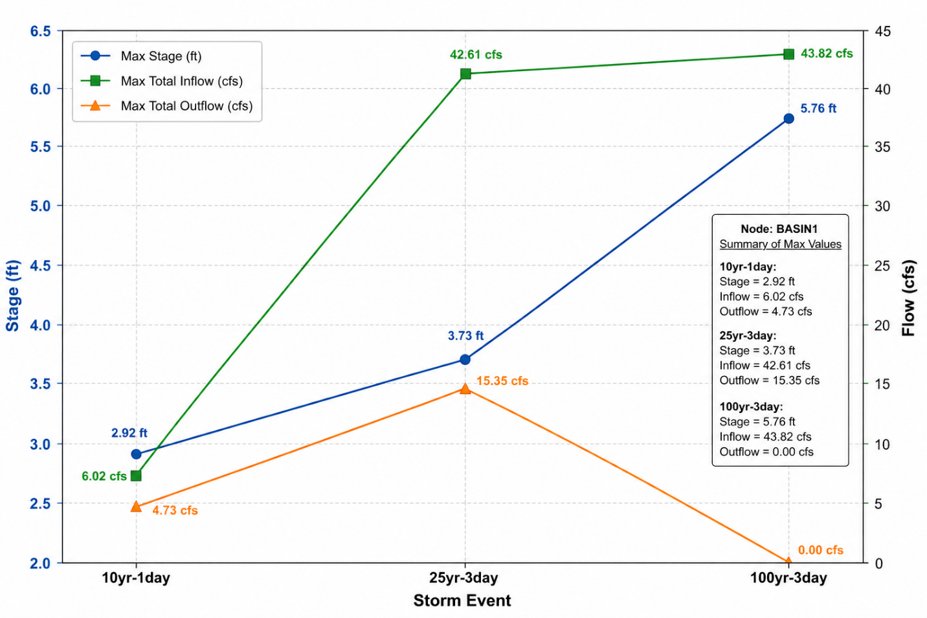
Figure 5. ICPR4 Modeled Peak Stage, Total Inflow, and Total Outflow by Storm Event (BASIN1)
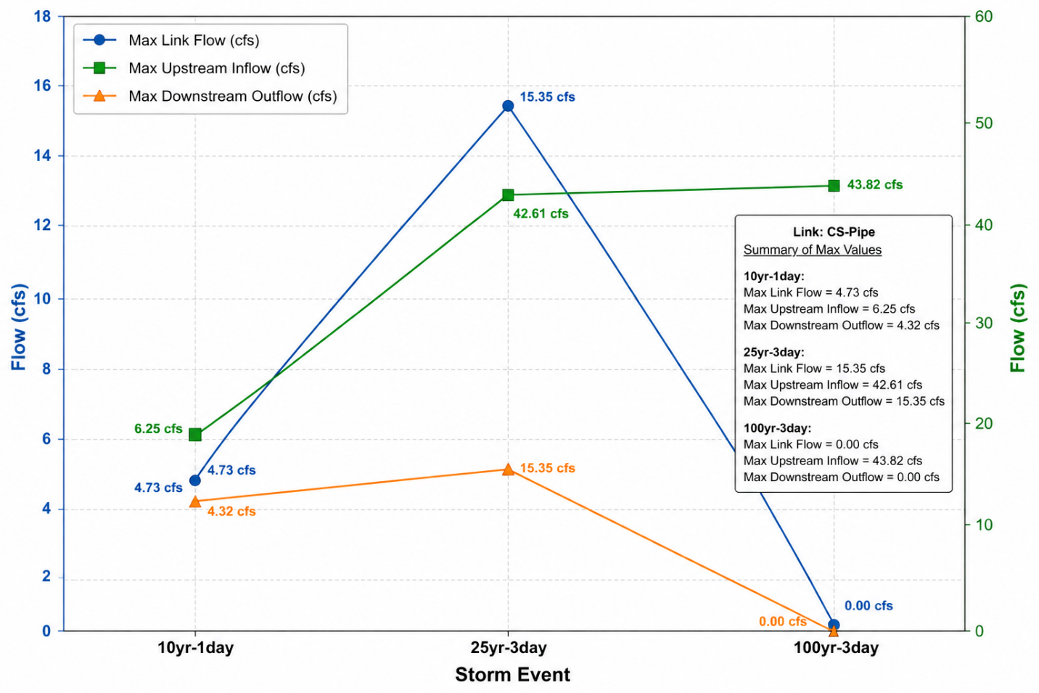Figure 6. ICPR4 Modeled Maximum Link Flow, Upstream Inflow, and Downstream Outflow by Storm Event (CS-Pipe)
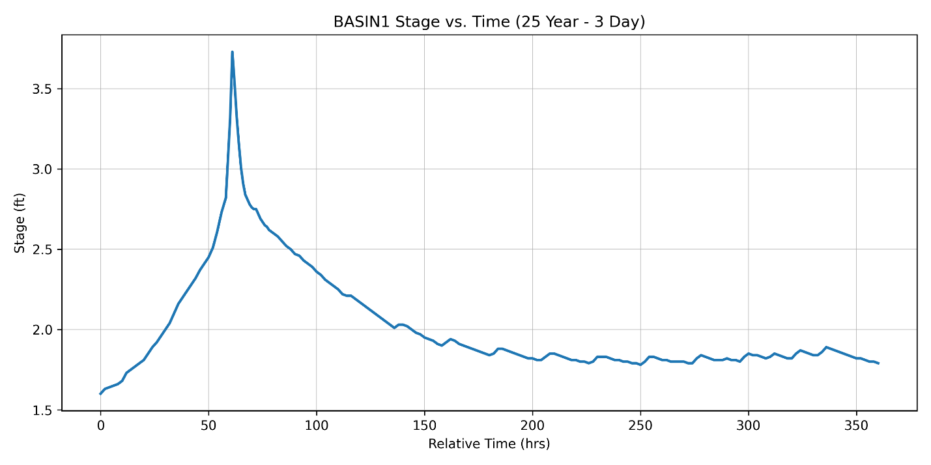Figure 7. ICPR4 Modeled Stage Hydrograph for the 25-Year, 3-Day Design Storm (BASIN1)

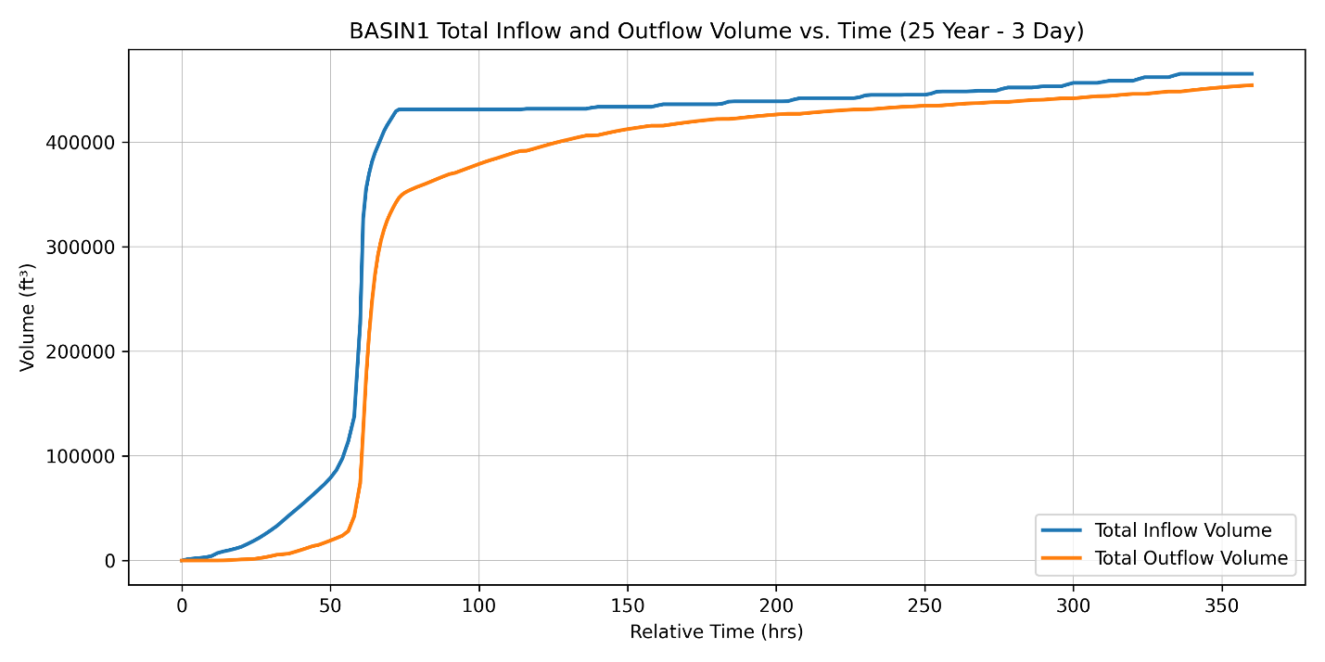
Figure 8. ICPR4 Modeled Inflow and Outflow Volume Hydrographs for the 25-Year, 3-Day Design Storm (BASIN1)

3.1.2 Nutrient Load and Water Quality Results
Finally, nutrient removal performance was evaluated using BMP Trains to assess compliance with updated SFWMD water quality criteria. Post-development conditions show an increase in runoff volume and nutrient loads due to higher impervious coverage (40% DCIA), with annual loads increasing from 23.11 to 24.74 kg/year for TN and from 3.84 to 4.12 kg/year for TP. This increase confirms that post development conditions lead to higher pollutants loading. The conventional system consisting of dry retention and wet detention alone was not sufficient to meet the required nutrient reduction targets. Therefore, an enhanced treatment system was implemented, incorporating a green roof, dry retention, wet detention, and stormwater harvesting system in series.
Results show that the integrated system significantly improves treatment performance, achieving 97% TN removal and 99% TP removal, both exceeding the required 95% reduction criteria. Following treatment, discharge loads were reduced to 0.68 kg/year for TN and 0.05 kg/year for TP, resulting in total mass reductions of 24.06 kg/year and 4.06 kg/year, respectively. These results demonstrate that green infrastructure components are essential to offset post-development increases in nutrient loading and to achieve compliance with stringent SFWMD criteria. Additional analysis confirms that stormwater harvesting and green roof systems reduce runoff volume and improve overall system efficiency by capturing and reusing approximately 1.24 acre-feet of runoff and reducing inflow to downstream treatment systems . Overall, the combined system effectively integrates hydraulic control and water quality treatment, meeting both flood protection and nutrient reduction requirements under the updated regulatory framework.
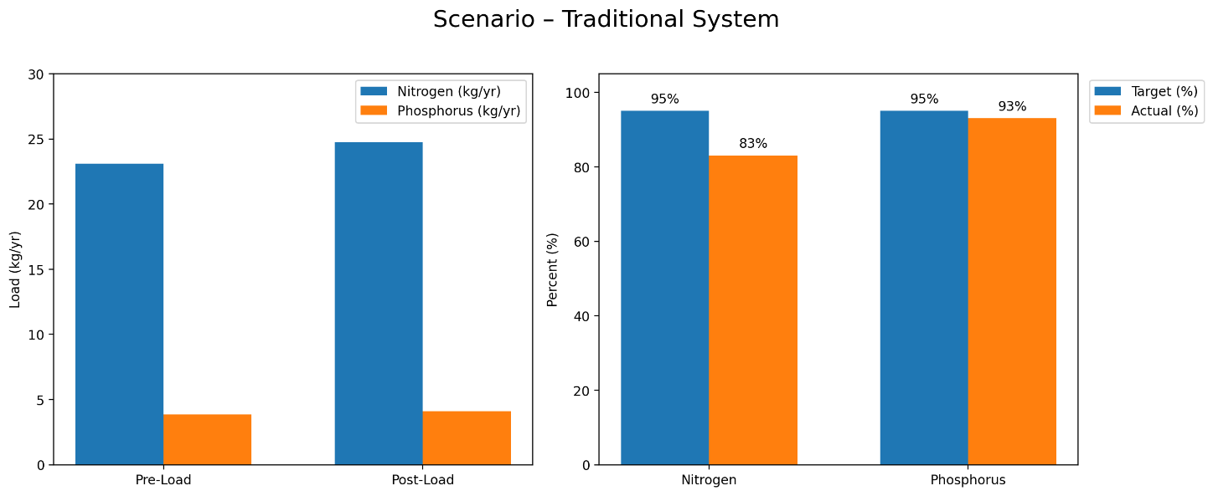
Figure 9. Scenario 1 – Traditional System performed

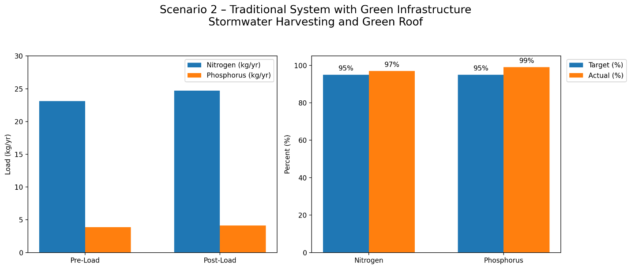
Figure 10. Scenario 2 - Traditional System plus green alternative performed

3.1.3 Comparison of Conventional and Green Infrastructure Scenarios
The overall performance of the proposed stormwater management system was evaluated by integrating hydrologic, hydraulic, and water quality analyses under post-development conditions. First, results indicate that the conventional system alone is not sufficient to meet updated nutrient reduction requirements due to increased runoff volumes associated with higher impervious coverage. The system manages an annual runoff volume of approximately 17.76 acre-feet from the 13.05-acre basin. This increase in runoff directly contributes to higher nutrient loading and reduced treatment efficiency under the baseline scenario. Next, the incorporation of green infrastructure significantly improves system performance, where a treatment train consisting of a green roof, dry retention, wet detention, and stormwater harvesting was implemented to address both water quantity and water quality objectives. The green roof reduces runoff at the source, while dry retention and wet detention provide sequential storage, infiltration, and extended residence time, enhancing pollutant removal efficiency. The stormwater harvesting component captures and reuses approximately 1.24 acre-feet of runoff for irrigation, further reducing discharge volumes. From a hydraulic perspective, both scenarios meet flood control requirements, maintaining acceptable peak stages for the 10-year, 25-year, and 100-year storm events and ensuring basin recovery between storms. However, the key difference is observed in water quality performance, where the integrated system achieves nutrient removal efficiencies of 97% for total nitrogen and 99% for total phosphorus, exceeding the required 95% reduction criteria for impaired waters. Finally, these results demonstrate that green infrastructure is necessary to offset post-development increases in runoff and pollutant loading, and provides a more effective and sustainable solution compared to conventional stormwater systems alone

3.1.4 Storage Recovery Performance
Next, system recovery performance was evaluated to verify compliance with regulatory drain-down requirements and system readiness for consecutive storm events. Three dry retention areas were analyzed for storage capacity and drain-down performance. Modeling confirms that all retention areas recover within the required 72-hour period following storm events, demonstrating compliance with SFWMD recovery criteria and confirming that sufficient storage is restored between storm events. In addition, the wet pond annual residence time was calculated at 197 days, which is within the maximum allowable limit of 200 days, indicating effective retention for water quality treatment without excessive stagnation. Figure 8 illustrates retention area recovery, showing that storage capacity is restored within the required timeframe, supporting reliable system performance under repeated rainfall conditions.

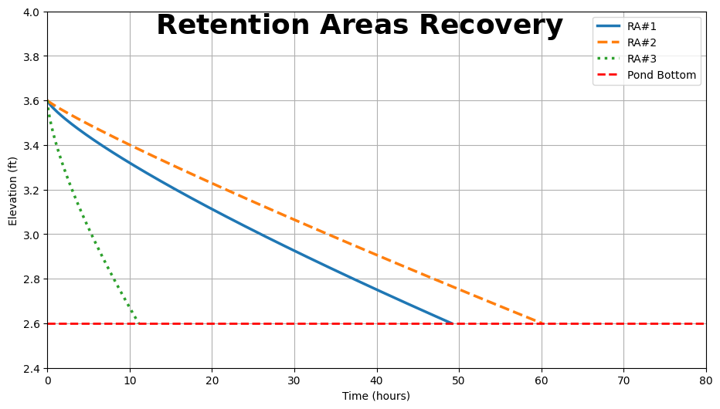
Figure 11. Retention Area Recovery

Discussion

4.1 Interpretation of Hydraulic Performance
First, the hydraulic results indicate that the proposed stormwater management system provides effective flood control and meets all required SFWMD and local design criteria under post-development conditions. The ICPR4 simulations confirm that peak water surface elevations remain below critical design thresholds, including berm elevations, roadway crowns, and finished floor elevations, demonstrating that the system can safely convey and store runoff during the 10-year, 25-year, and 100-year design storm events. In addition, discharge rates remain within allowable limits, indicating that the system does not adversely impact downstream receiving waters. The recovery analysis further supports system reliability, as all retention areas drain within the required 72-hour period, ensuring that storage capacity is restored between consecutive storm events. The cascading configuration, where runoff is routed from dry retention to wet detention, enhances hydraulic performance by providing staged storage and controlled release, which reduces peak flows and improves system stability. Overall, these results confirm that the proposed system is hydraulically resilient and capable of performing under both typical and extreme rainfall conditions common in coastal South Florida.

4.2 Interpretation of Nutrient Reduction Results
Next, the nutrient analysis demonstrates the significant impact of development on water quality and the importance of advanced treatment strategies to meet regulatory requirements. The increase in impervious areas leads to higher runoff volumes, which directly increases total nitrogen and phosphorus loads, even when event mean concentrations remain unchanged. The results show that the conventional system, consisting of dry retention and wet detention, is not sufficient to meet the required 95 percent nutrient reduction criteria under the updated SFWMD standards. However, the integration of green infrastructure components, including a green roof and stormwater harvesting, substantially improves system performance. These components reduce runoff at the source, increase treatment time, and enhance pollutant removal efficiency throughout the treatment train. As a result, the system achieves removal efficiencies of approximately 97 percent for total nitrogen and 99 percent for total phosphorus, exceeding regulatory requirements. These findings highlight that source control, and reuse strategies are essential for managing water quality in highly developed and impaired watersheds.

4.3 Implications for Stormwater Design under Updated Criteria
Then, the findings of this study have important implications for stormwater system design under the updated Florida environmental permitting criteria. The results indicate that traditional stormwater systems alone may no longer be sufficient to meet current regulatory requirements, particularly in coastal areas with impaired receiving waters. Achieving compliance often requires increased storage capacity, which can lead to higher land demand and reduced developable area. However, the integration of green infrastructure provides a more efficient alternative by improving system performance without significantly increasing spatial requirements. In this study, the use of green roof and stormwater harvesting systems reduced runoff volumes and enhanced nutrient removal, allowing the system to meet regulatory criteria more effectively. These results suggest that future stormwater designs should prioritize hybrid approaches that combine conventional infrastructure with green alternatives to balance regulatory compliance, land use constraints, and long-term sustainability.

4.4 Limitations and Uncertainty
The scope of this study is limited to the evaluation of stormwater system performance using modeling tools and does not include direct field validation or long-term monitoring of water quality improvements. The analysis is based on several modeling assumptions, including curve number values, event mean concentrations, rainfall distributions, and boundary conditions, which may vary under actual site conditions. In addition, ICPR4 and BMP Trains, while widely accepted in Florida permitting practice, rely on simplified representations of complex hydrologic and water quality processes, introducing uncertainty in predicted results. The development of a comprehensive mass balance within a coastal stormwater system is inherently complex, as multiple interacting variables, including groundwater conditions, tidal influence, and runoff variability, may be subject to unknown or unanticipated sources of error. Furthermore, factors such as maintenance practices, sediment accumulation, vegetation growth, operational conditions, and climate variability may influence long-term system performance but are not fully captured in the modeling framework. Despite these limitations, every effort was made to use reliable data and account for known sources of uncertainty, and the modeling approach provides a consistent and practical basis for evaluating stormwater system performance under current regulatory conditions; however, future research should incorporate field validation, long-term monitoring, and evaluation of nature-based infrastructure strategies to improve model accuracy and system reliability.

Conclusions
This study evaluated the performance of a stormwater management system for a redevelopment site in Fort Myers Beach using ICPR4 and BMP Trains modeling under the updated SFWMD Criteria of Evaluation. Results confirm that post-development conditions increase runoff volume and nutrient loading due to higher impervious coverage, reinforcing the need for enhanced treatment strategies beyond conventional stormwater systems. Next, the integrated system composed of green roof, dry retention, wet detention, and stormwater harvesting demonstrates the ability to meet both hydraulic and water quality requirements, providing adequate storage, controlled discharge, and compliance with all required design storm criteria. The system achieves nutrient removal efficiencies exceeding regulatory thresholds, confirming that the incorporation of green infrastructure is essential for meeting the 95 percent reduction requirements for impaired waters. These findings directly address the research objective by demonstrating that conventional systems alone are insufficient under updated criteria, while hybrid systems significantly improve performance and regulatory compliance. Furthermore, green infrastructure components reduce runoff at the source and enhance treatment efficiency, supporting more sustainable and resilient stormwater design. Finally, while the proposed system meets current standards, long-term performance will depend on proper maintenance and monitoring, and future work should evaluate cost-effective nature-based infrastructure strategies to optimize system efficiency, land use, and long-term feasibility in coastal environments.
Key Findings
- Traditional stormwater systems require additional volume storage and open space to meet updated Florida environmental permitting criteria due to increased treatment and performance requirements.
- Green infrastructure significantly improves stormwater system performance under updated criteria by reducing runoff, enhancing nutrient removal, and offsetting the need for additional open space.
6.0 Ethical Considerations
Ethical considerations for this study include environmental protection by minimizing impacts, maintaining water quality, and preserving nearby ecosystems in SFWMD. Ethical considerations focus on environmental and engineering responsibility, including accurate representation of site conditions, responsible use of modeling software, and transparent reporting of results. All data supporting the project is publicly accessible, and analysis will be shared in accordance with professional and academic standards.

7.0 AI Assistance Statement
The authors declared that Gen AI was used in the creation of this manuscript. AI assistance from GPT-5.3 was utilized for providing review comments, refining text for succinctness and clarity, providing suggestions for restructuring paragraphs to improve logic flow, and performing semantic analysis of qualitative survey responses. For the literature review, ChatGPT-5.3 was used to develop ideas and synthesize content. All literature was provided for analysis. AI contributions were verified and contextualized to ensure accuracy and relevance to the study’s objectives. The author has reviewed and edited the output and content of this publication.

8.0 Supplementary Materials
The supporting information and backups used for this proposal research can be find at: https://github.com/HiginioH/rm.git

9.0 Acknowledgments
The author would like to acknowledge the support provided by Oscar Lugo, PE and the research assistance provided by Ahmed S. Elshall, Ph.D, during the preparation of this research.

10.0 Conflicts of Interest
There are no known conflicts of interest associated with this project. All environmental data used in the analysis is publicly available as part of the ERP permit application, and no proprietary or restricted information was utilized.

11.0 References
Aguiar, C. R., J. K. Nuernberg, and T. C. Leonardi (2020), Multicriteria GIS-based approach in priority areas analysis for sustainable urban drainage practices: A case study of Pato Branco, Brazil, Eng, 1, 96–111, https://doi.org/10.3390/eng1020006
Burr, D. C. S. (2008), Impervious surface analysis of the Estero Bay watershed in Lee County, Florida, M.S. thesis, Florida Gulf Coast Univ., https://scholarscommons.fgcu.edu/esploro/outputs/99383341684106570
Collier County (2025), Land development code, https://library.municode.com/fl/collier_county/codes/code_of_ordinances
Davtalab, R., S. Ghotbi, R. Koushki, and C. L. Reynolds (2024), Assessing the resilience of stormwater ponds under climate change: A case study on Grace Lake, Florida, Journal of Hydrology, 633, 130987, https://doi.org/10.1016/j.jhydrol.2024.130987
Federal Emergency Management Agency (FEMA) (2025), Flood Insurance Rate Maps, https://msc.fema.gov/portal/home
Florida Senate (2025), Florida Statutes, Section 373.4131: Statewide environmental resource permitting rules, https://www.flsenate.gov/Laws/Statutes/2025/373.4131
Harper, H. H., and D. M. Baker (2007), Evaluation of current stormwater design criteria within the state of Florida, Fla. Dep. Environ. Prot.
Joyce, J., N.-B. Chang, R. Harji, T. Ruppert, and S. Imen (2017), Developing a multi-scale modeling system for resilience assessment of green-grey drainage infrastructures under climate change and sea level rise impact, Environmental Modelling & Software, 90, 1–26, https:/doi.org/10.1016/j.envsoft.2016.11.026
National Oceanic and Atmospheric Administration (NOAA) (2025), NOAA Atlas 14 precipitation frequency estimates, https://hdsc.nws.noaa.gov/pfds/
National Oceanic and Atmospheric Administration (NOAA) (2025), Tides and currents station 8725520, https://tidesandcurrents.noaa.gov/stationhome.html?id=8725520
Rentachintala, L. R. N. P., M. G. M. Reddy, and P. K. Mohapatra (2022), Urban stormwater management for sustainable and resilient measures and practices: A review, Water Sci. Technol., 85(4), 1120–1140, https://doi.org/10.2166/wst.2022.017
Schroeder, D. W., S. Tsegaye, T. L. Singleton, and K. K. Albrecht (2022), GIS- and ICPR4-based approach to sustainable urban drainage practices: Case study of a development site in Florida, Water, 14(10), 1557, https://doi.org/10.3390/w14101557
South Florida Water Management District (SFWMD) (2024), Environmental resource permit applicant’s handbook, vol. I, https://www.sfwmd.gov/sites/default/files/documents/swerp_applicants_handbook_vol_i.pdf
South Florida Water Management District (SFWMD) (2024), Environmental resource permit applicant’s handbook, vol. II, https://www.sfwmd.gov/sites/default/files/documents/archive_swerp_applicants_handbook_vol_ii_20240628.pdf
South Florida Water Management District (SFWMD) (2025), Environmental resource permitting, https://www.sfwmd.gov/doing-business-with-us/permits
Streamline Technologies, Inc. (2025), Interconnected Channel and Pond Routing (ICPR4) model, https://streamline.tech/resources/gis-and-ICPR4
Tsegaye, S., T. L. Singleton, A. K. Koeser, D. S. Lamb, S. M. Landry, S. Lu, J. B. Barber, D. R. Hilbert, K. O. Hamilton, and R. J. Northrop (2019), Transitioning from gray to green (G2G): A green infrastructure planning tool for the urban forest, Urban For. Urban Green., 40, 204–214, https://doi.org/10.1016/j.ufug.2018.09.005
Wanielista, Martin; Hardin, Mike; Gogo-Abite, Ikiensinma; and Chopra, Manoj, "Stormwater Harvesting Using Retention and In-Line Pipes for Treatment Consistent with the new Statewide Stormwater Rule" (2013). BMP Trains Research and Publications. 21.
https://stars.library.ucf.edu/bmptrains-research/21
Wanielista, M. (2005), Stormwater intelligent control system, BMP Trains Research and Publications, Univ. of Central Florida, https://stars.library.ucf.edu/bmptrains-research/19

